InformNet tests and exams use online proctoring through Brightspace with a tool called Integrity Advocate. Please review the information below before starting any test or exam.

What You Need Before You Start
- A computer with a web browser
- A working webcam and microphone
- A second device with a camera (smartphone or tablet)
- Valid photo identification (driver’s license, student card, or passport)
You must be fully set up before starting a proctored assessment.

Integrity Advocate – Level 3
- Live photo and photo ID verification (you may block sensitive details like your address)
- Webcam and microphone monitoring during the assessment
- No software downloads or browser extensions required
- Secure, encrypted sessions reviewed by trained human reviewers
- A second device provides a wider view of your testing area
- The second camera is connected using a secure QR code (no app required)

During a Proctored Assessment, You Must:
- Remain fully visible on camera at all times
- Stay in full-screen mode (unless your teacher allows uploads for long-answer questions)
- Follow all on-screen instructions provided by the proctoring system
You Must NOT:
- Communicate with anyone else
- Use collaborative tools, messaging apps, or social media
- Use headphones or earbuds
- Read the test questions aloud
- Use any AI tools or applications
- Use external resources unless explicitly permitted by your teacher
- Use smart devices (phones, tablets, smartwatches), except when approved for uploads
- Leave the testing area or have others present
- Stop screen sharing or use additional monitors

Need a Webcam?
- You can turn your phone into a webcam for free using: https://iriun.com/
- Make sure your phone and computer are on the same Wi-Fi network and that your browser has camera permissions enabled.

Important Reminder
- If proctoring is enabled and you are not properly set up (camera off, no photo ID, rules not followed), your assessment may be flagged for review.
- For more details on what to expect, visit: https://www.integrityadvocate.com/what-to-expect/informnet
- If you have questions or concerns before your assessment, contact your teacher or InformNet support.

Integrity Advocate LEVEL 3 Setup
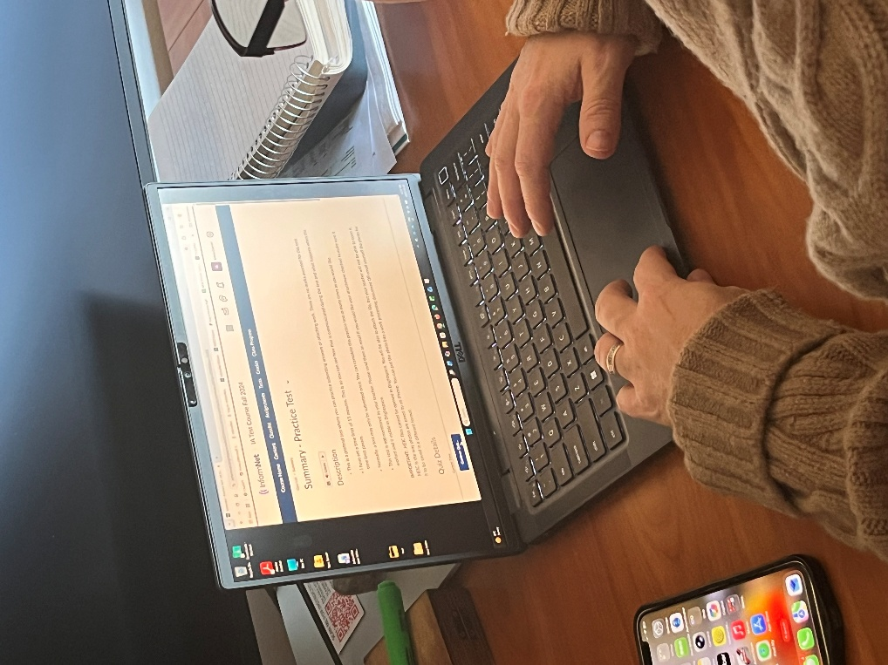
- Start the Quiz/Test

- Integrity Advocate will start.
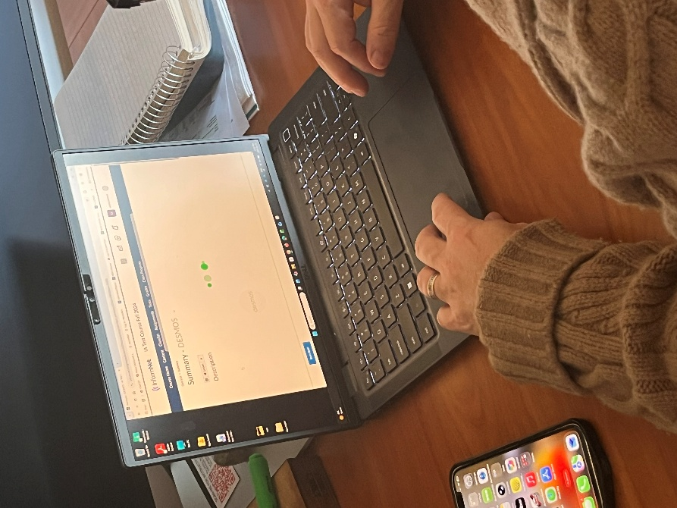
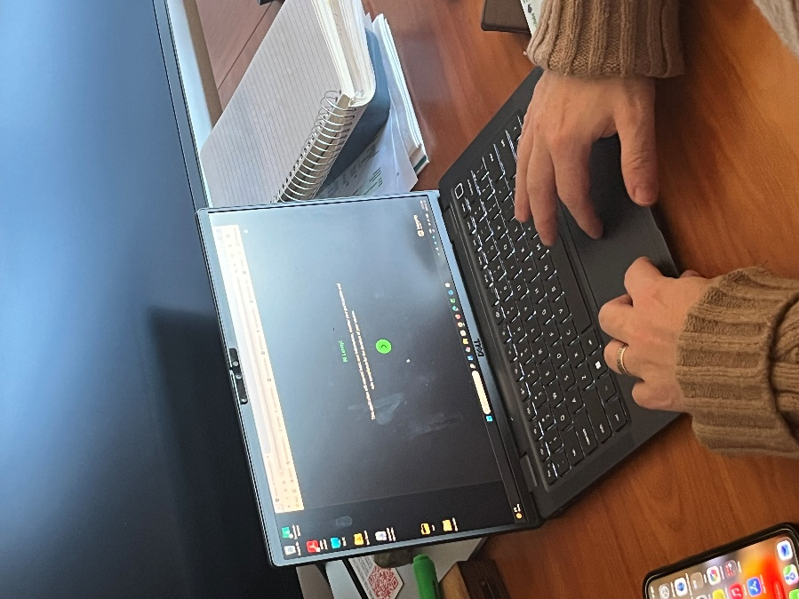

- Setup your camera and ID

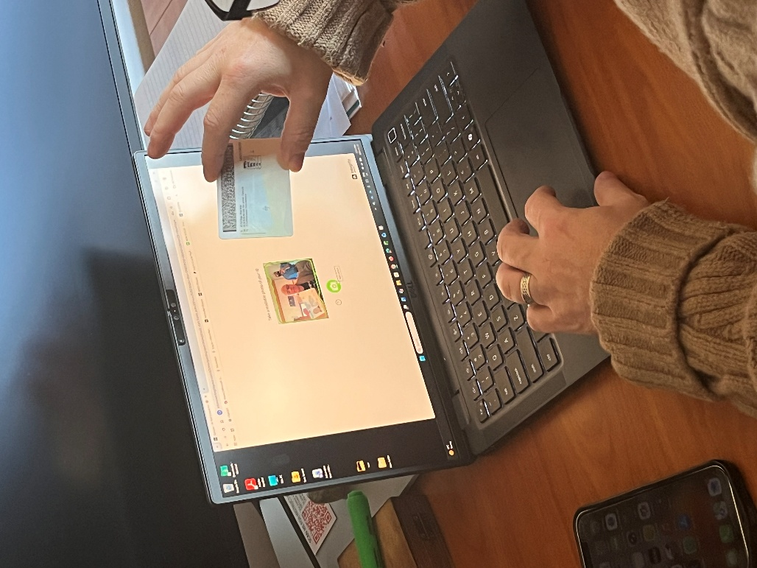
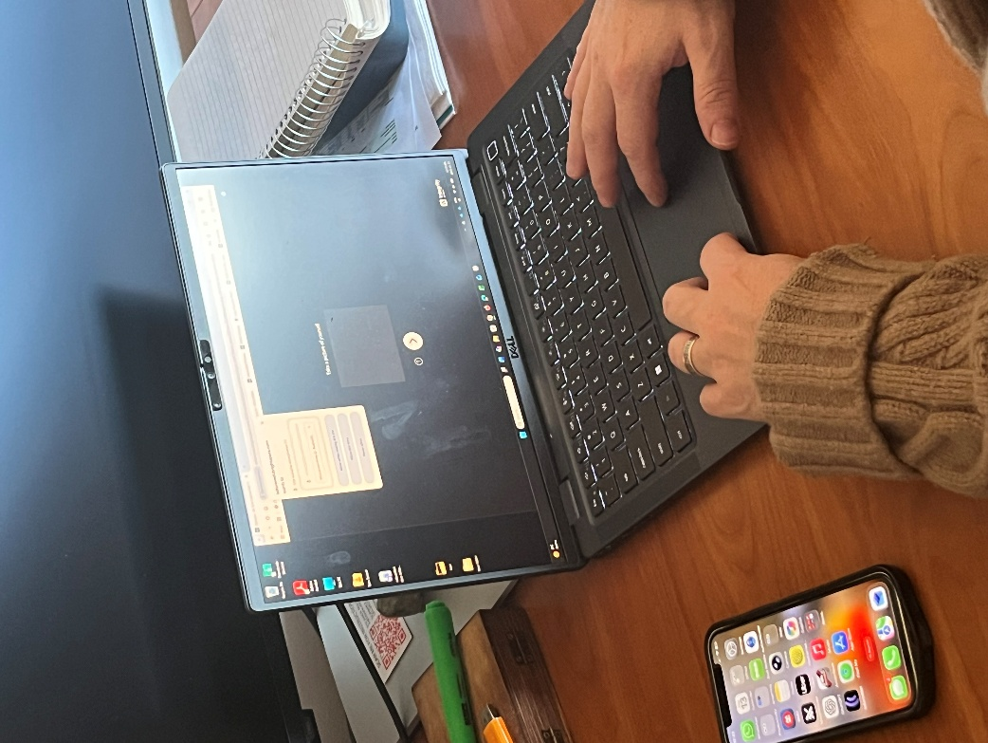

- Secondary Camera Setup:
  - QR CODE and your smart device. – Take a picture
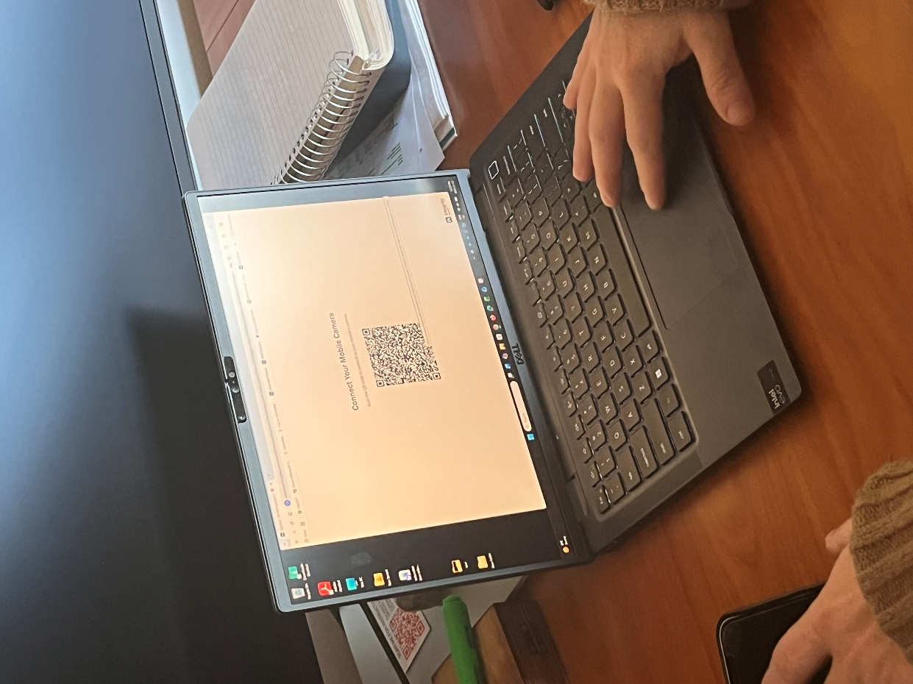
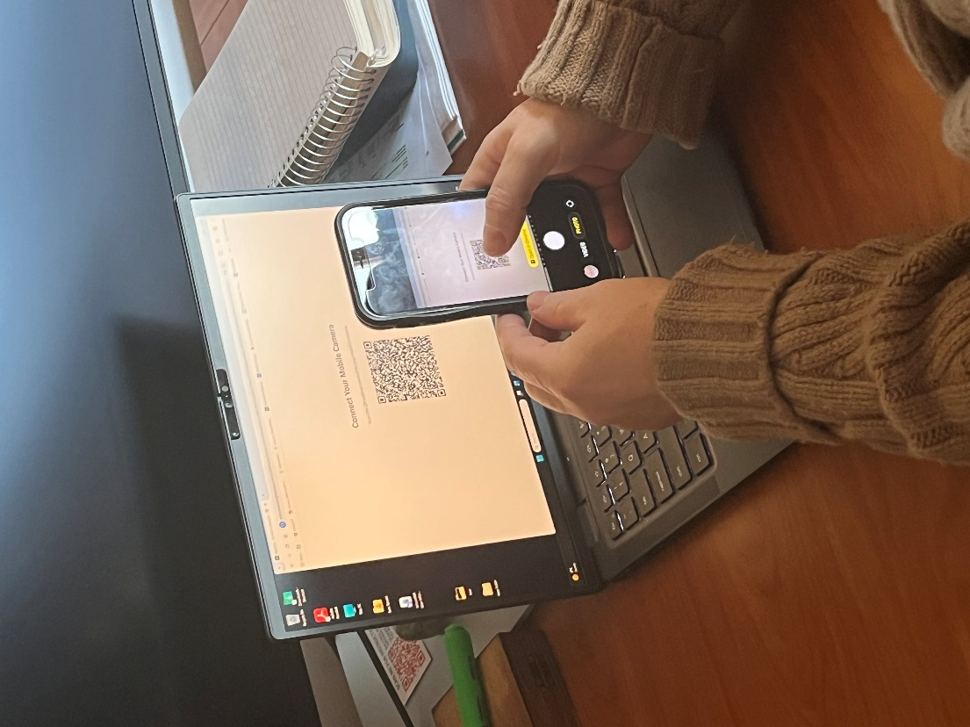

- Configure your smart device/2nd camera

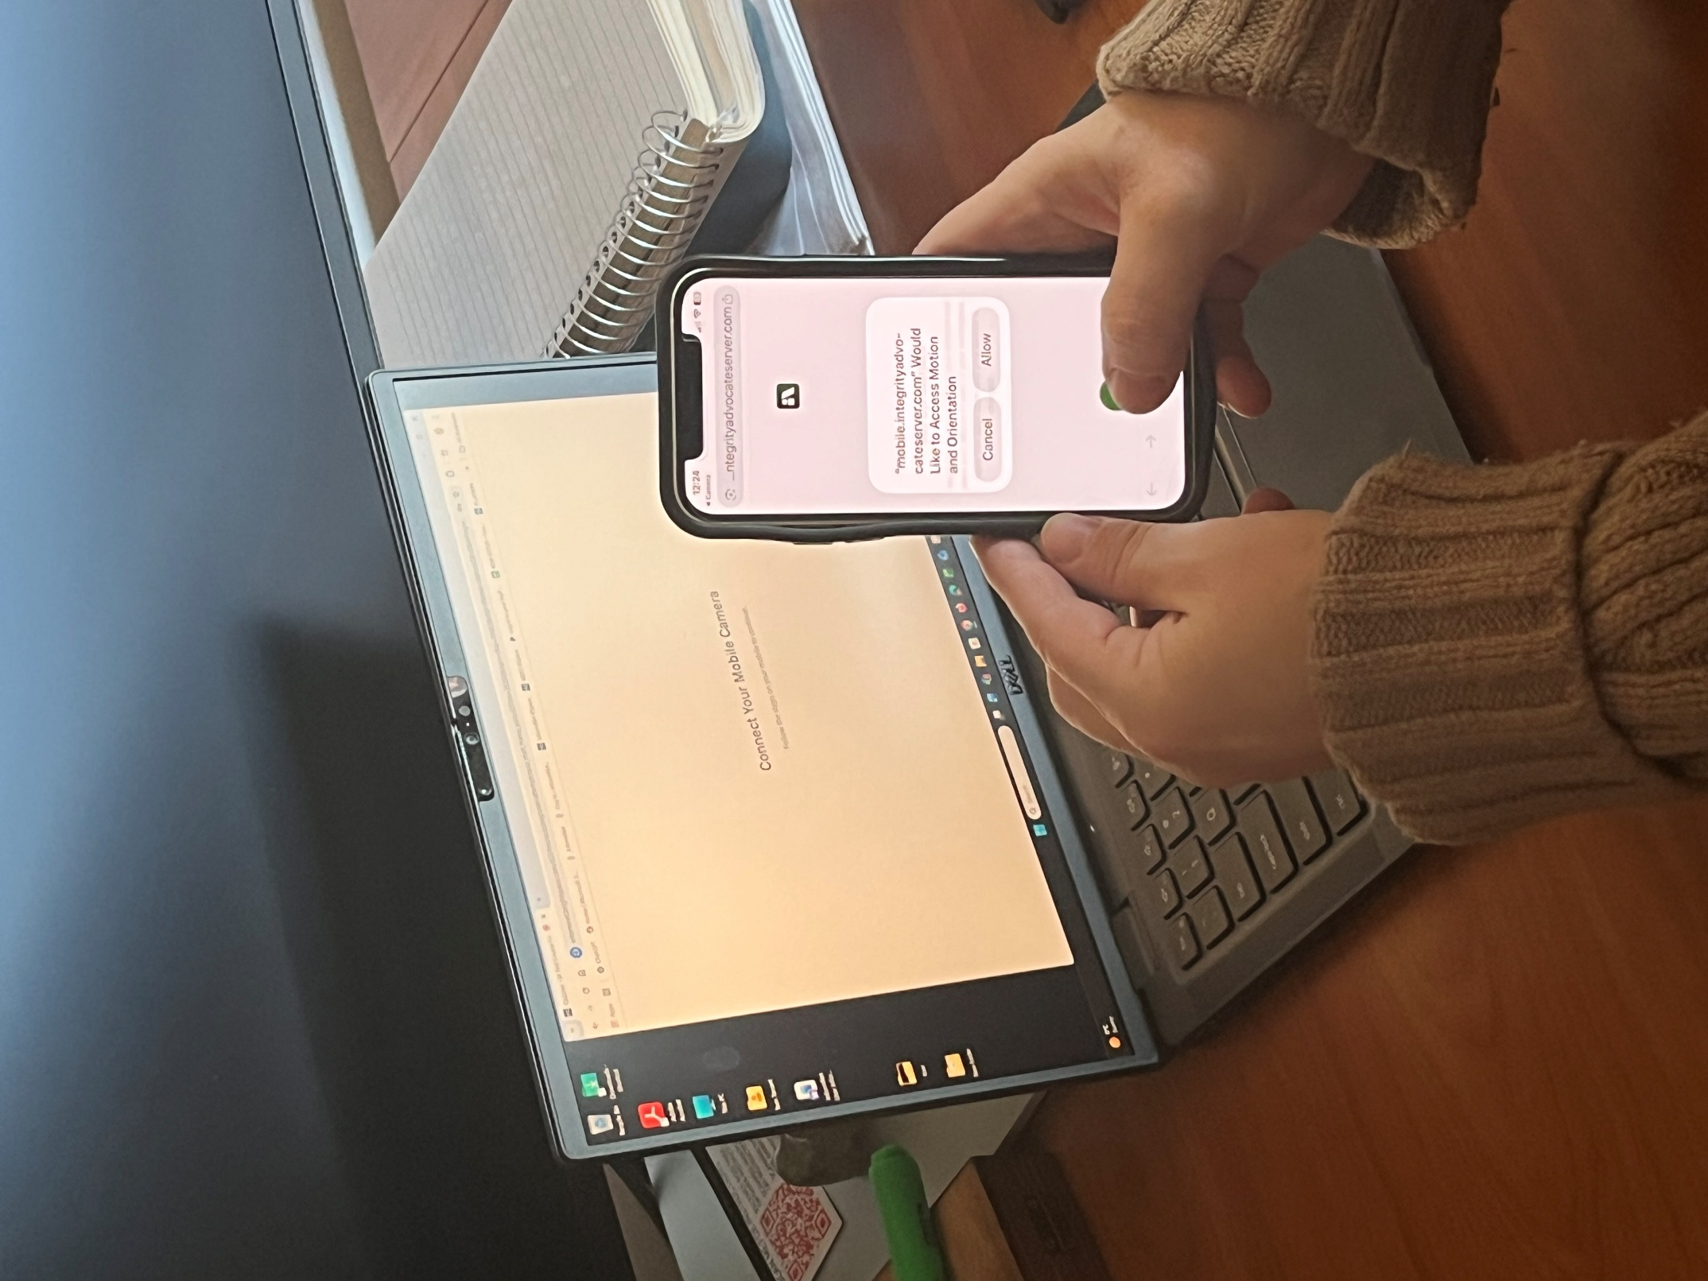
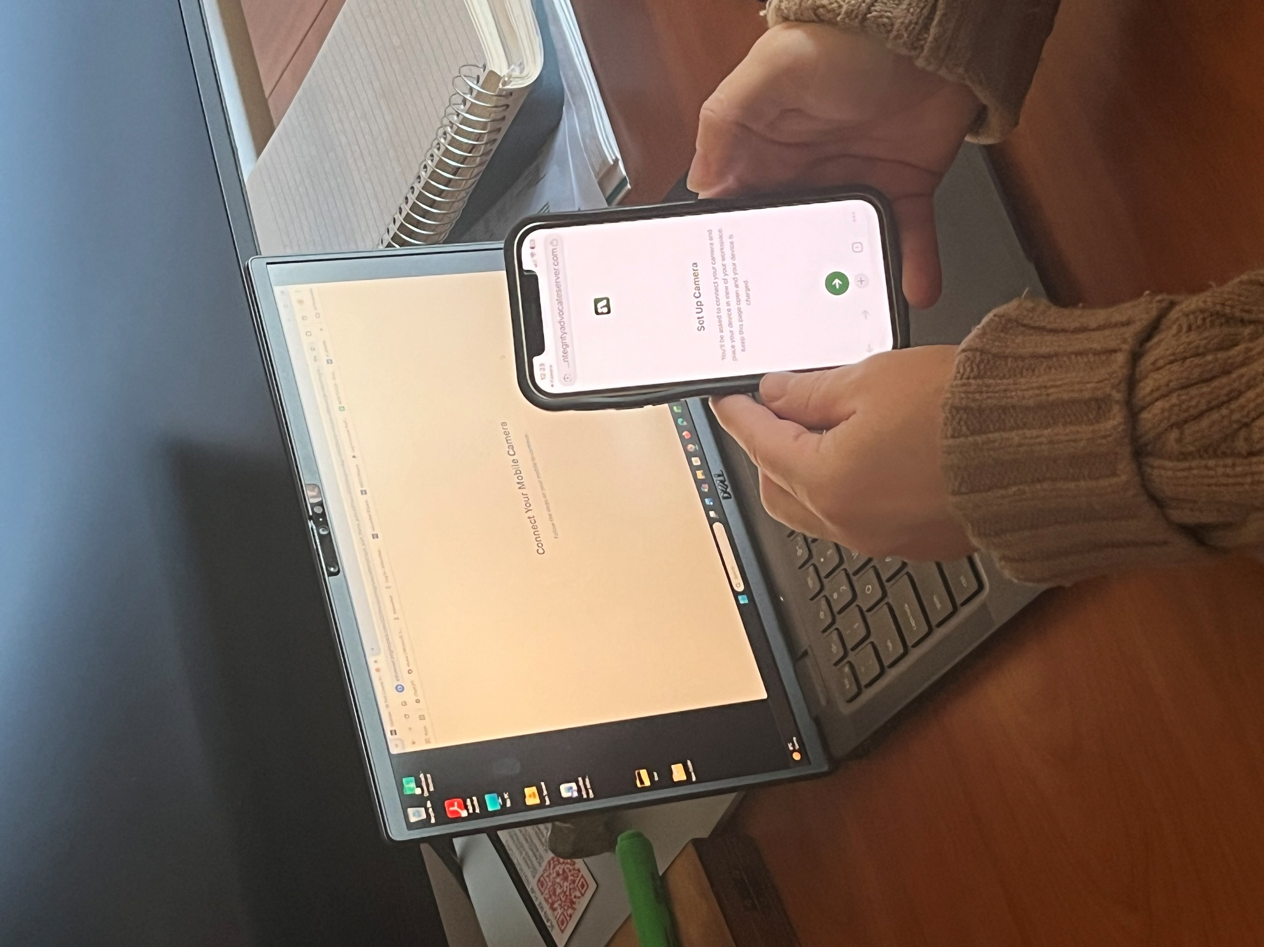

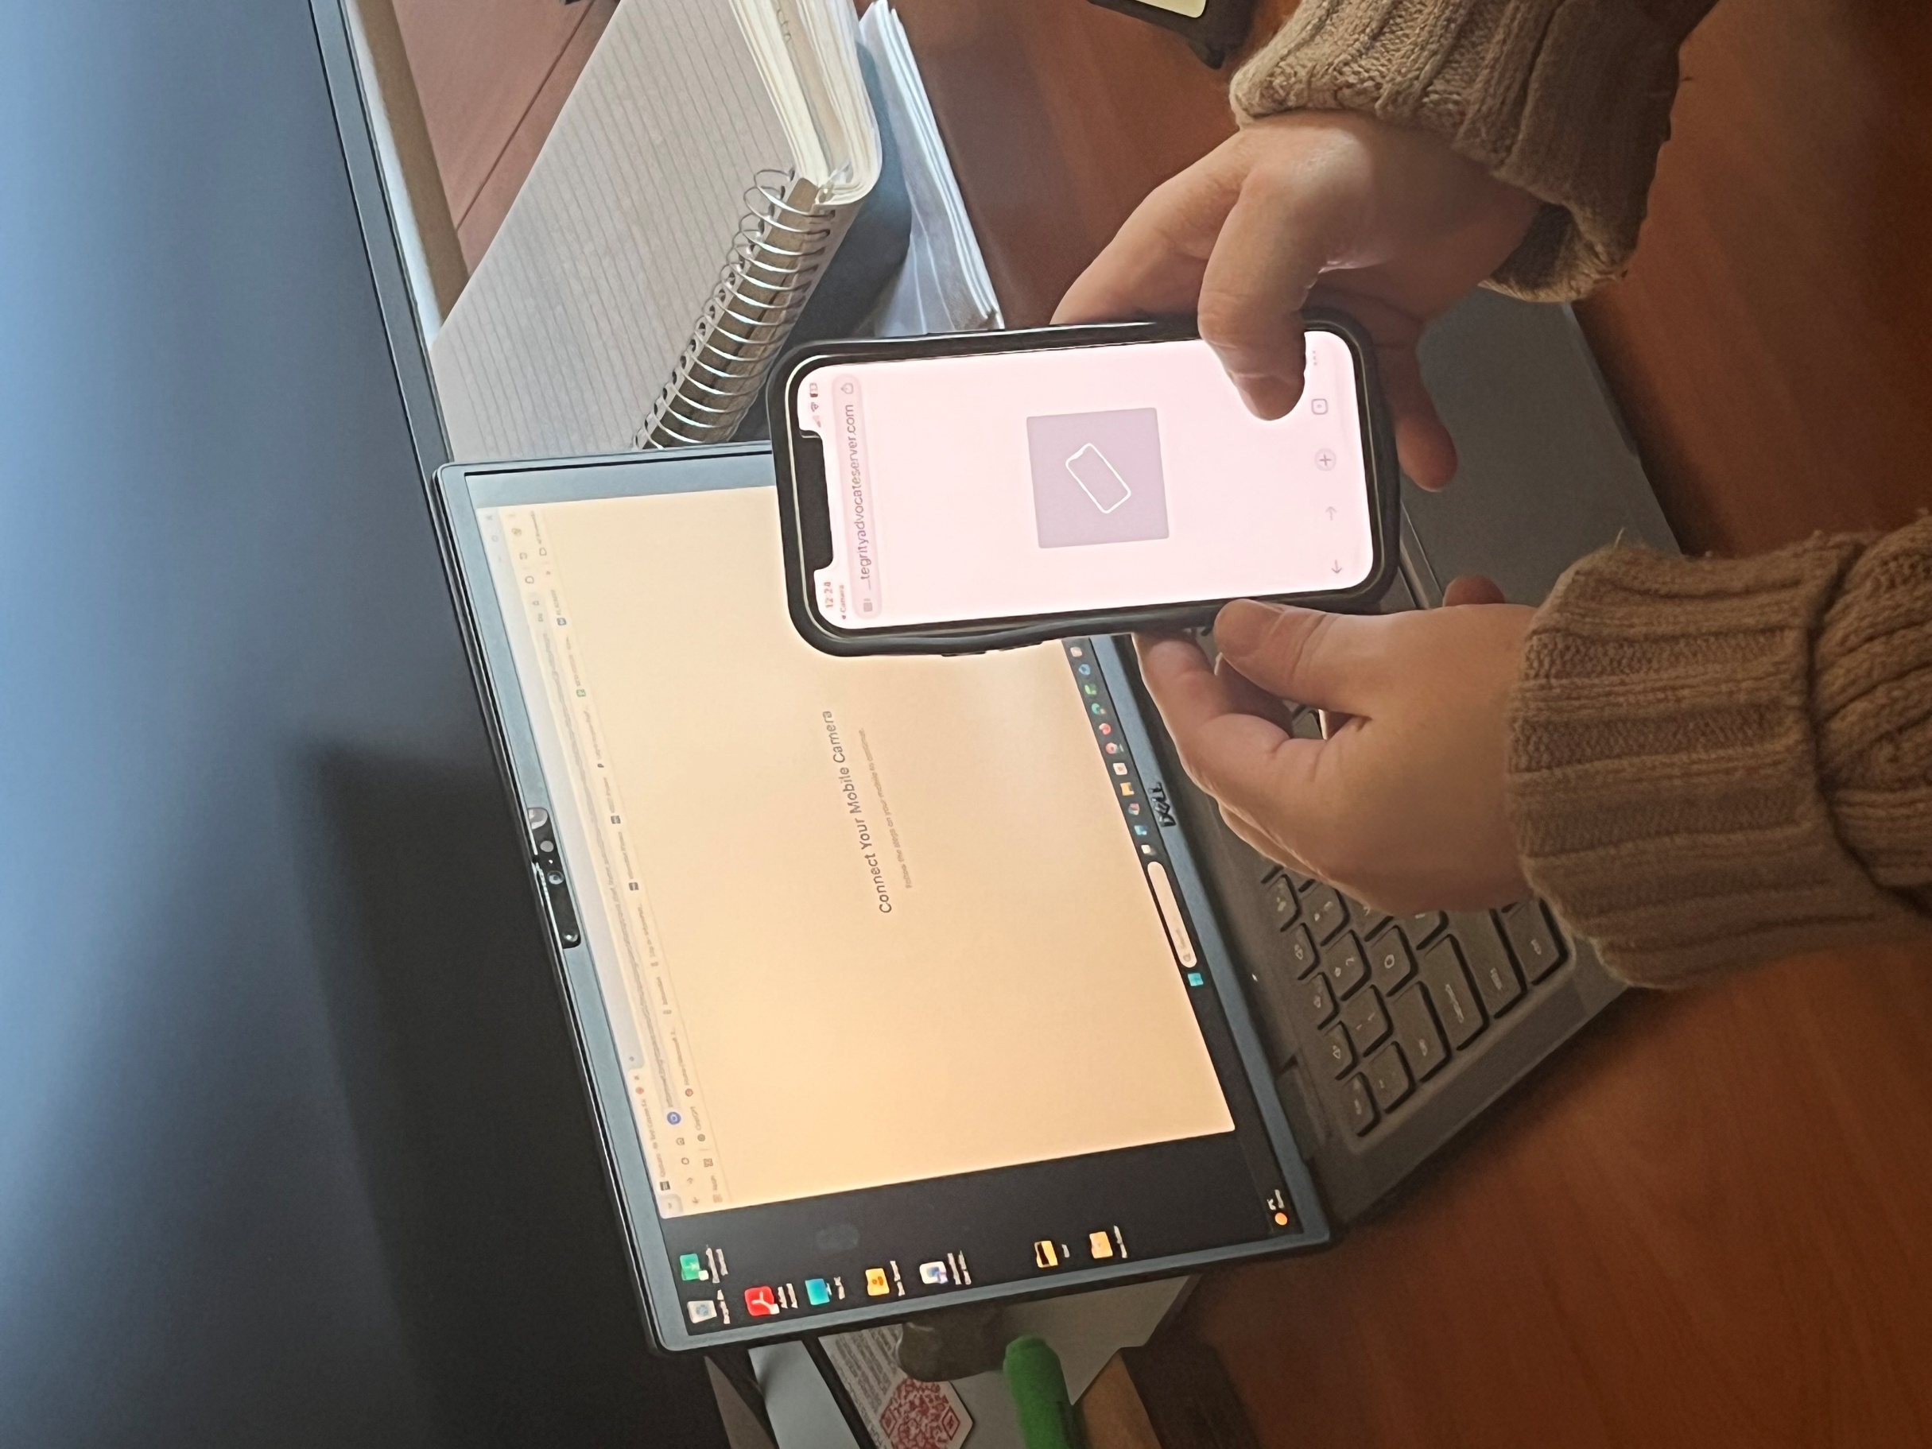
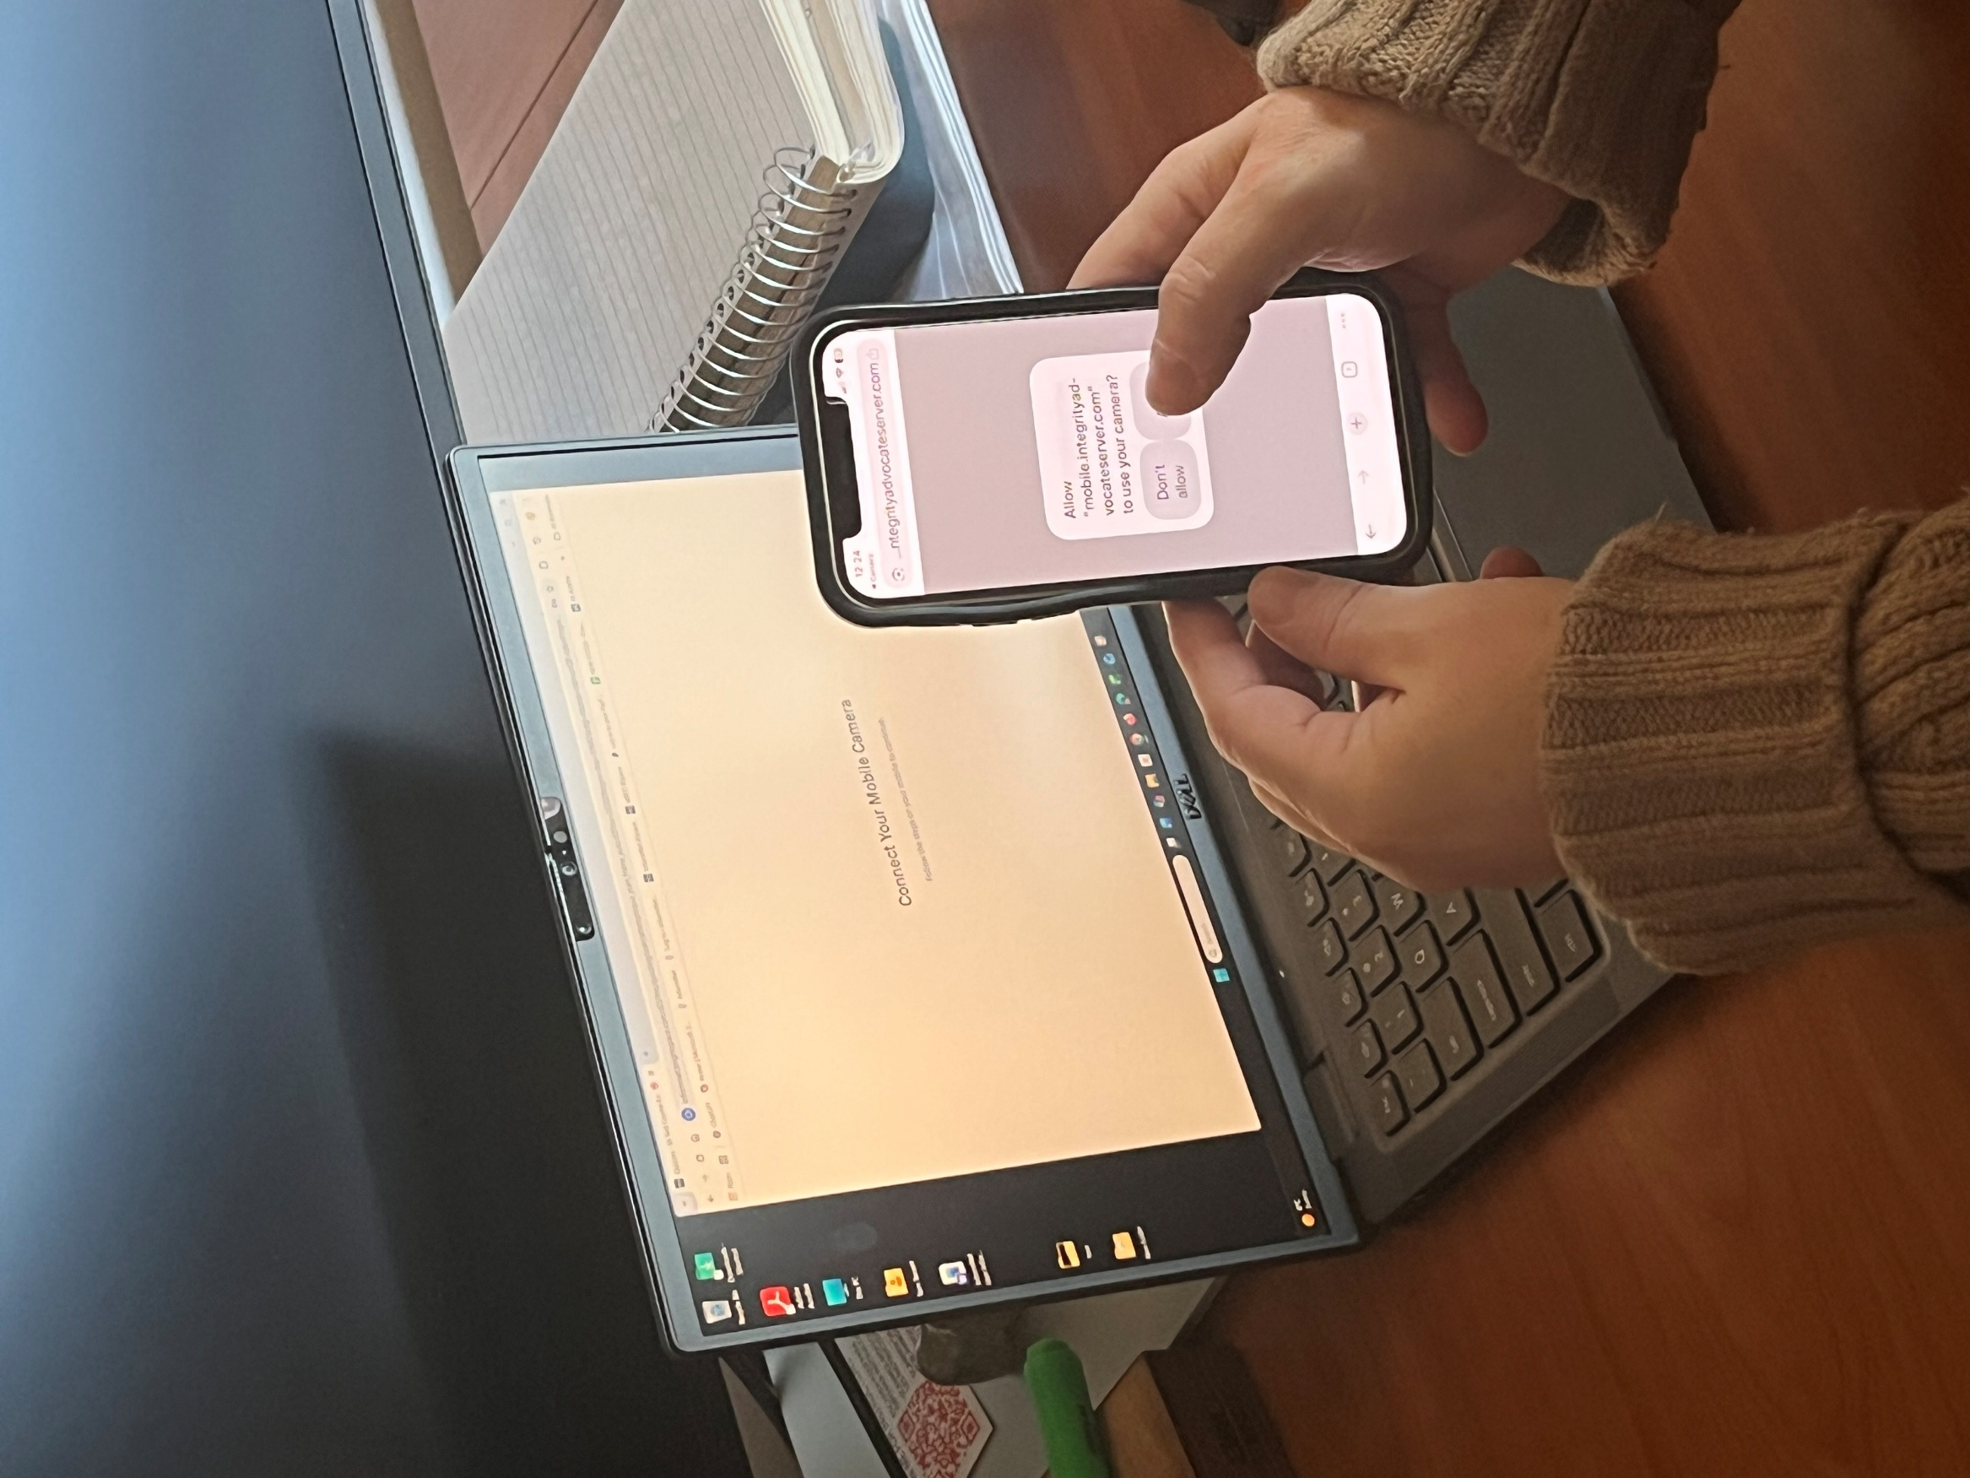

- Smart device/2nd camera placement – show you, your workspace and your screen
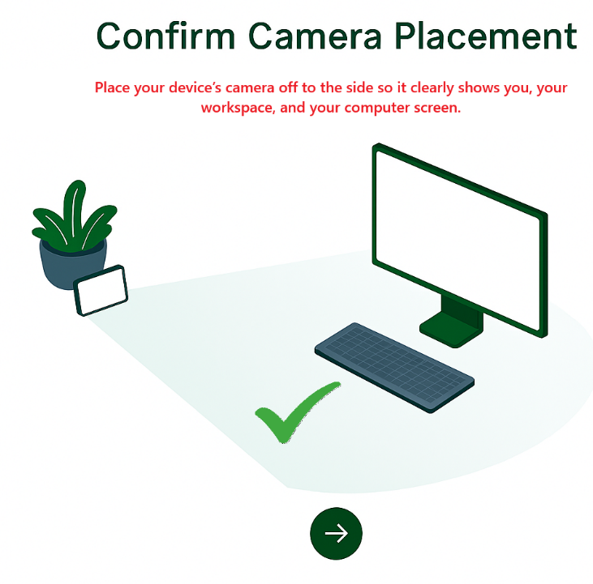



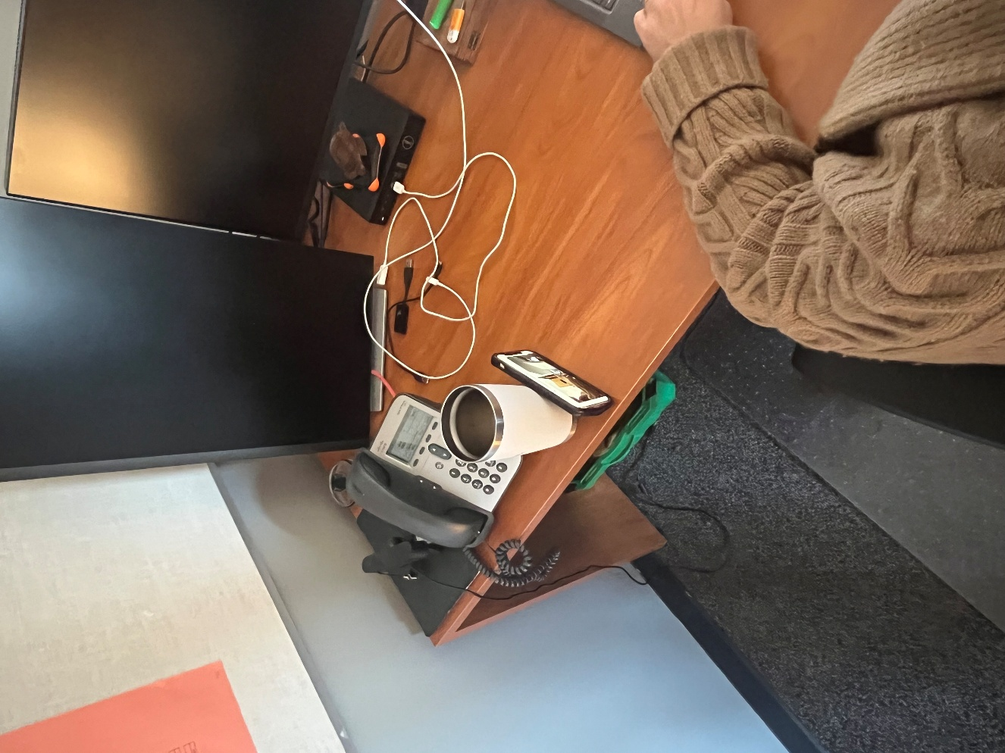
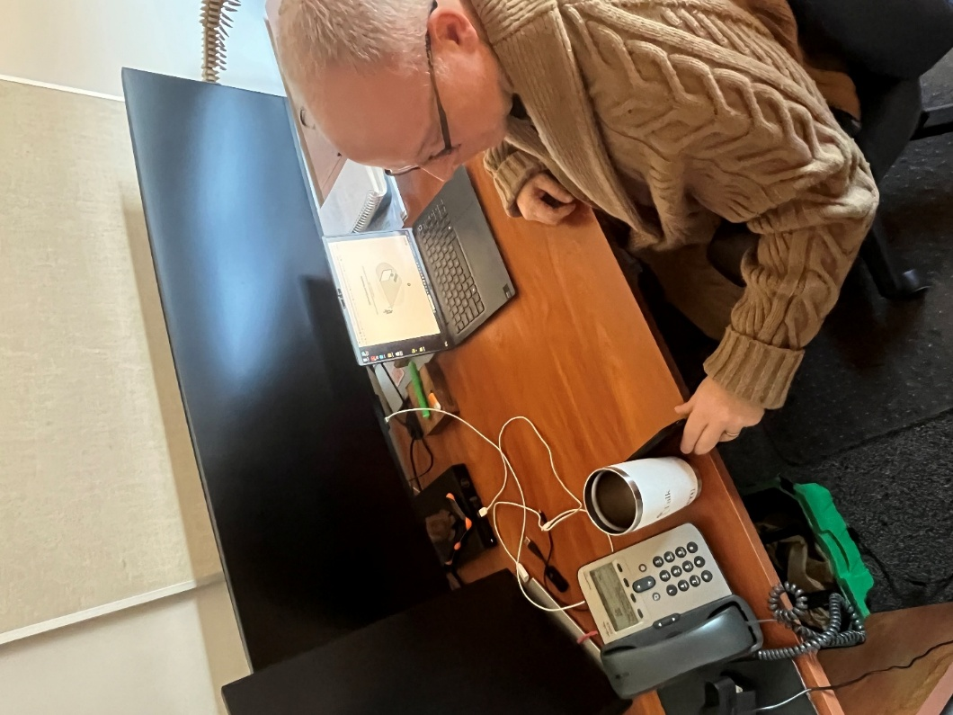

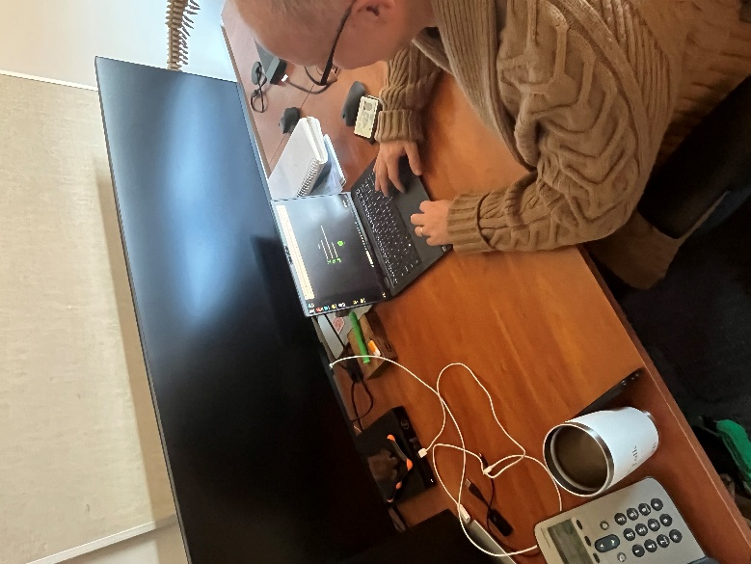

The second camera must clearly show you, your workspace (including anything you are using for the test), and your computer screen.

